Jenkins Pipeline Task

- Create one Declarative pipeline job
Source Code: https://github.com/shaikhshahbazz/spring3-mvc-maven-xml-hello-world-1.git
Repo: spring3-mvc-maven-xml-hello-world-1
Steps
Step 1: Install Required Tools
- Jenkins
- Git
- Maven
- JDK
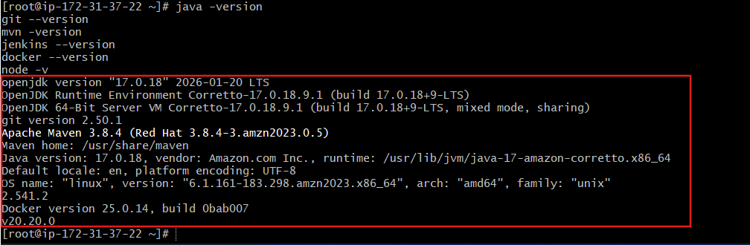
Manage Jenkins → Global Tool Configuration:
- Add JDK
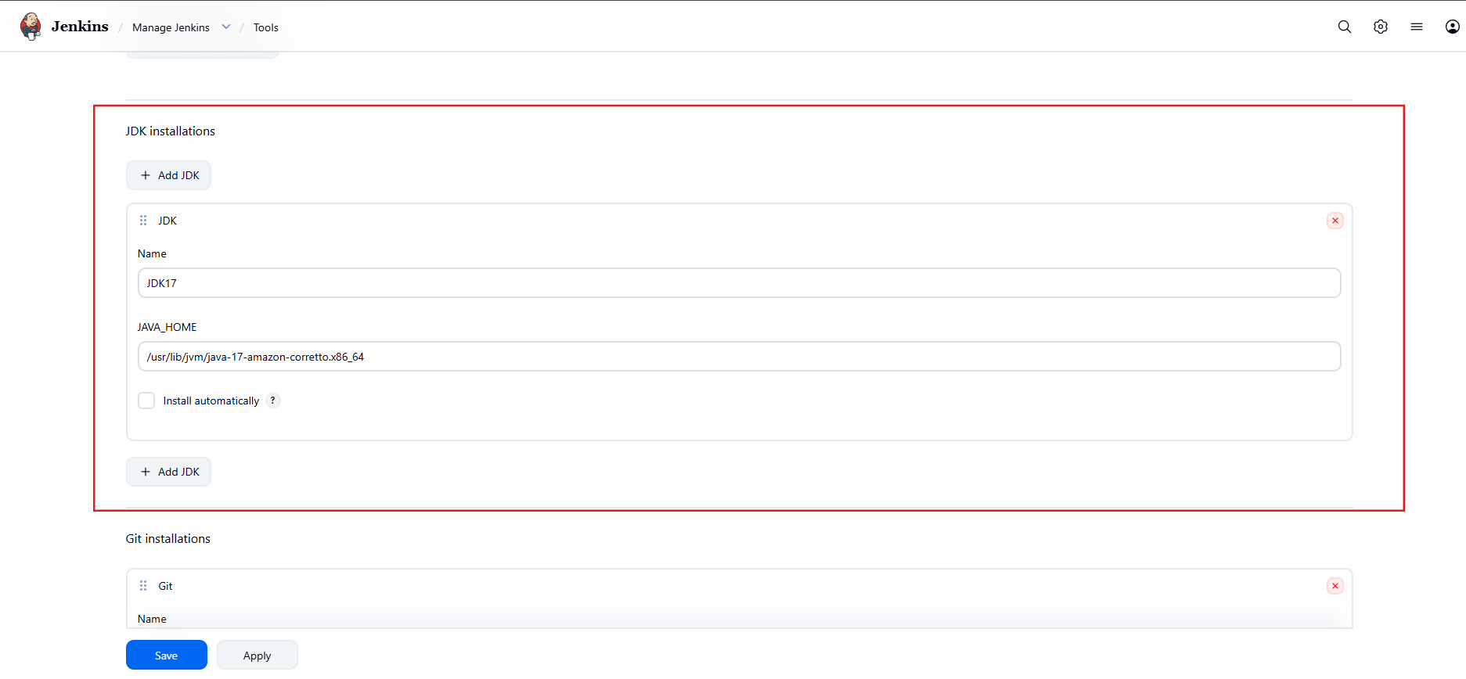
- Add Maven
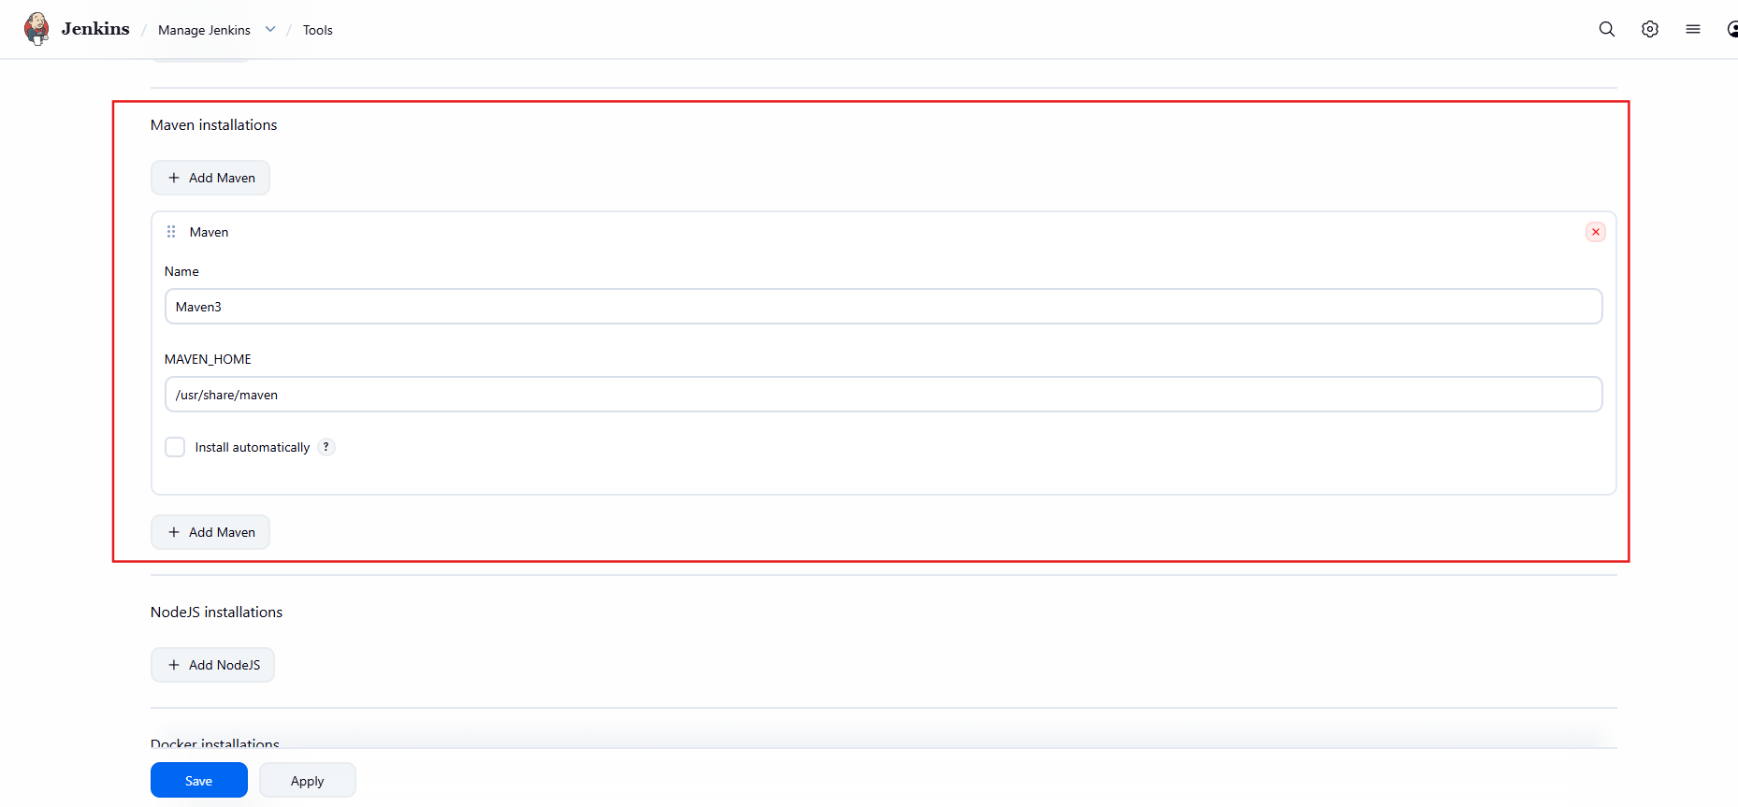
- Add Git
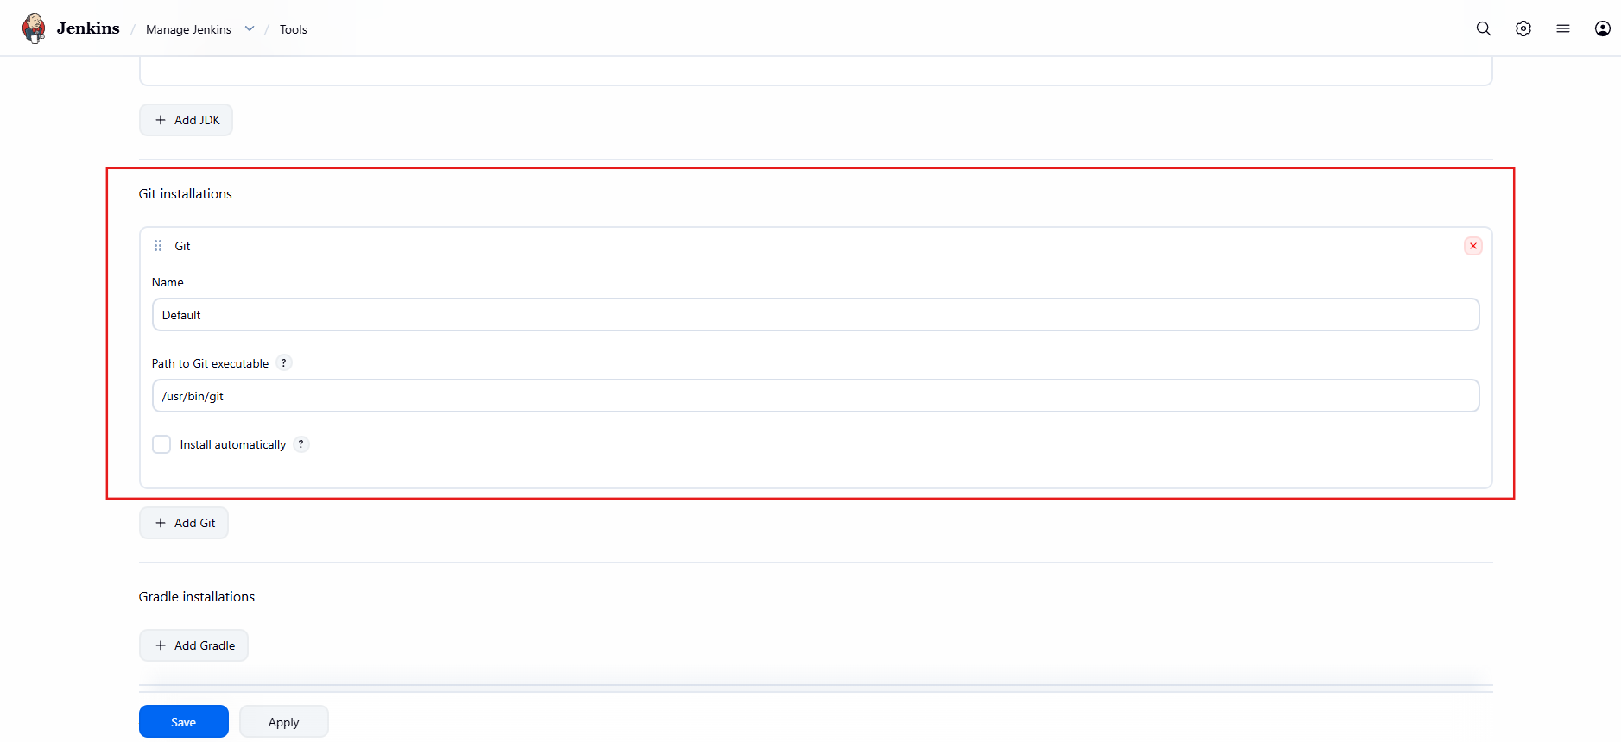
Step 2: Create Pipeline Job
- Jenkins Dashboard → New Item
- Enter Name → Spring-MVC-Declarative
- Select Pipeline
- Click OK
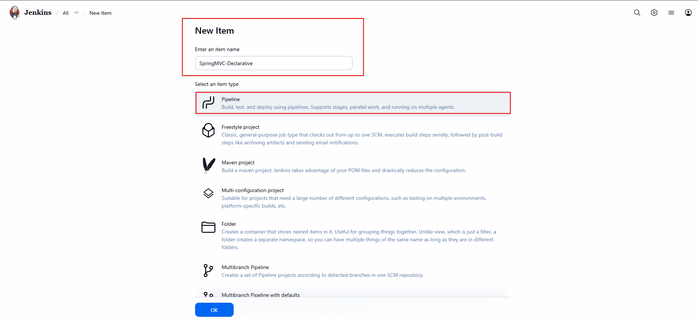
Step 3: Configure Pipeline
Scroll to Pipeline Section:
- Definition → Pipeline script from SCM
- SCM → Git
- Repository URL:
https://github.com/shaikhshahbazz/spring3-mvc-maven-xml-hello-world-1.git
- Branch: */master
- Script Path: Jenkinsfile
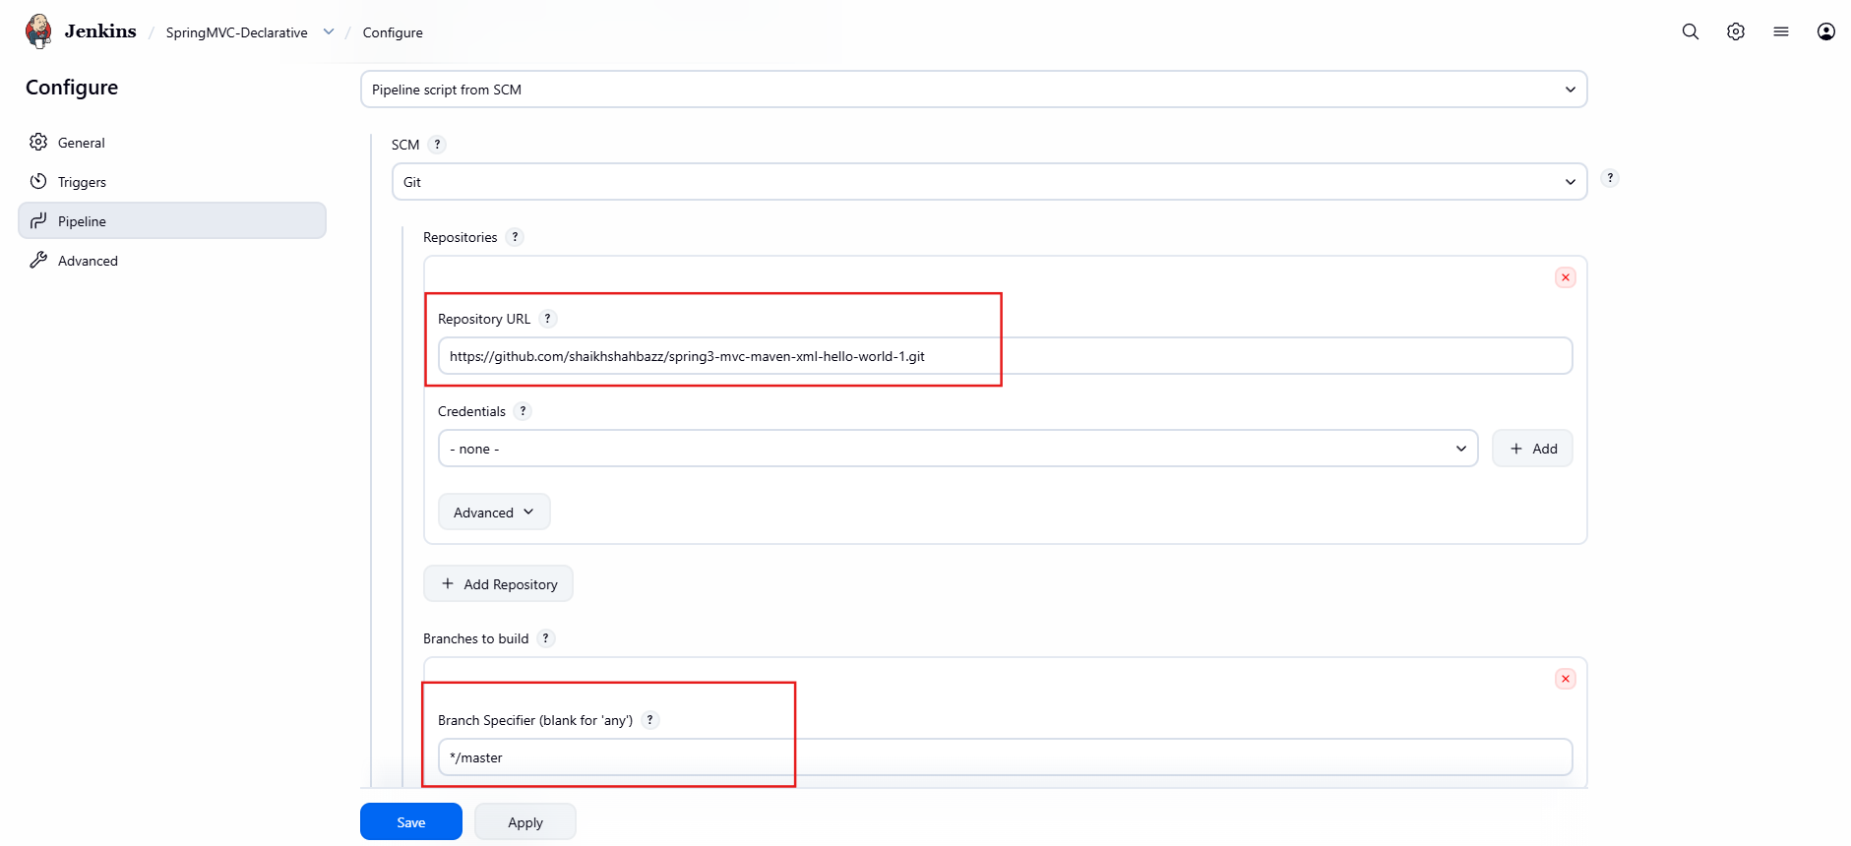
Step 4: Add Jenkinsfile to Repo
Create Jenkinsfile in repo:
pipeline {
agent any
tools {
maven 'Maven3'
jdk 'JDK17'
}
stages {
stage('Checkout') {
steps {
git 'https://github.com/shaikhshahbazz/spring3-mvc-maven-xml-hello-world-1.git'
}
}
stage('Build') {
steps {
sh 'mvn clean package'
}
}
stage('Test') {
steps {
sh 'mvn test'
}
}
}
post {
success {
echo 'Build Successful!'
}
failure {
echo 'Build Failed!'
}
}
}
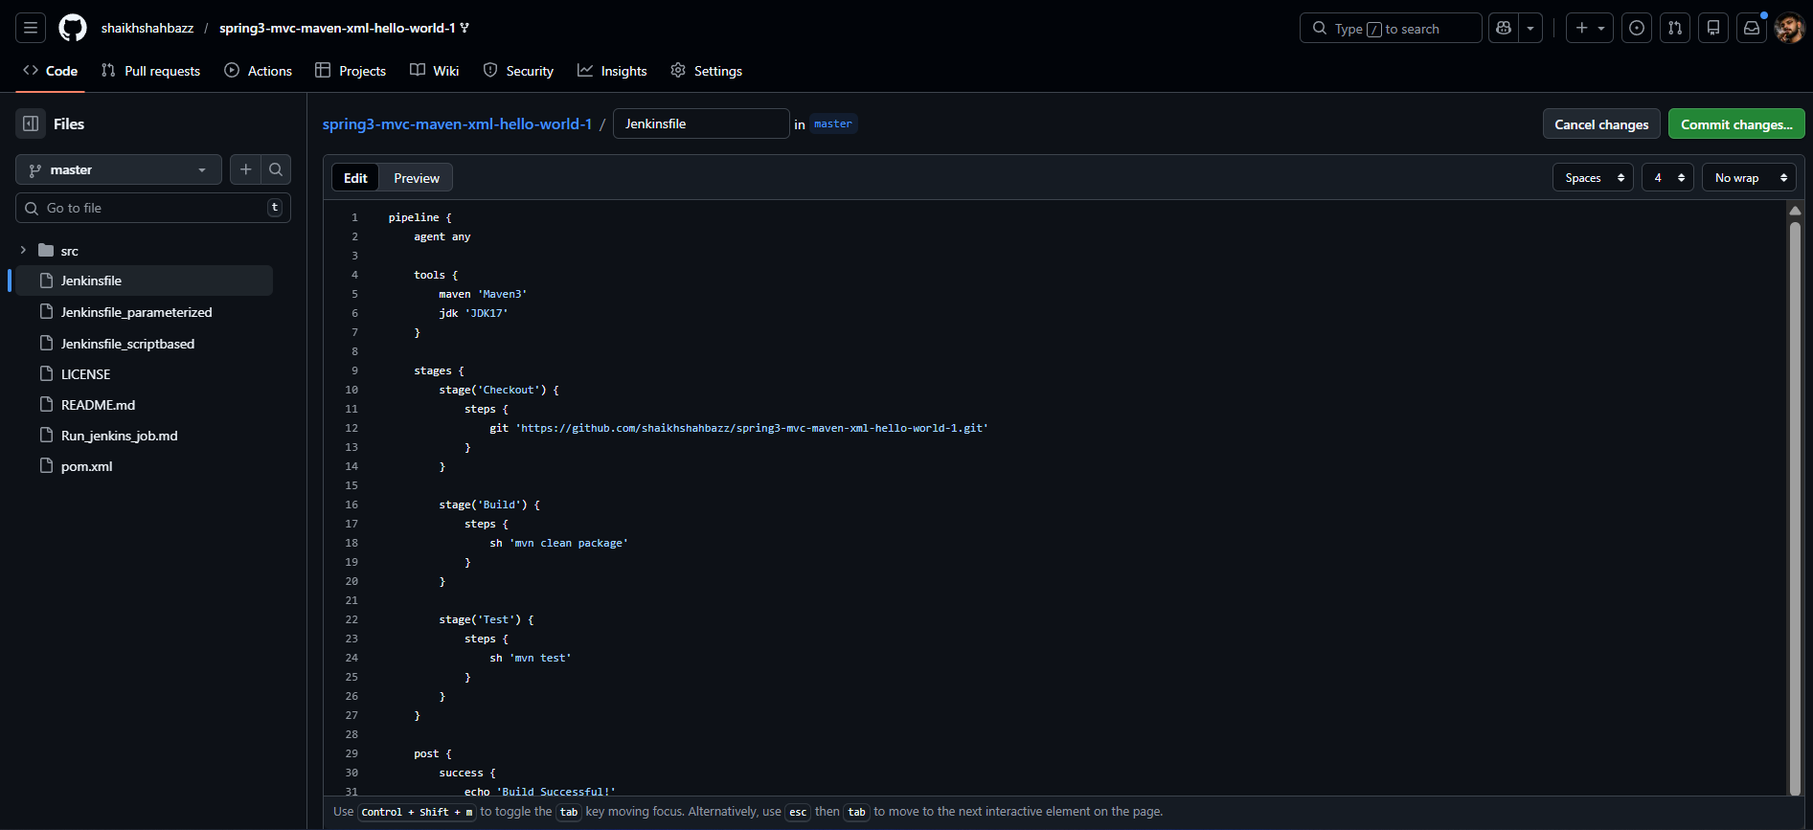

Explanation
- pipeline {} → Declarative syntax
- agent any → Runs on any node
- tools → Auto-configures Maven & JDK
- stages → Defines pipeline stages
- post → Runs after build

Validation
✔ Console Output shows:
BUILD SUCCESS
✔ Green build status
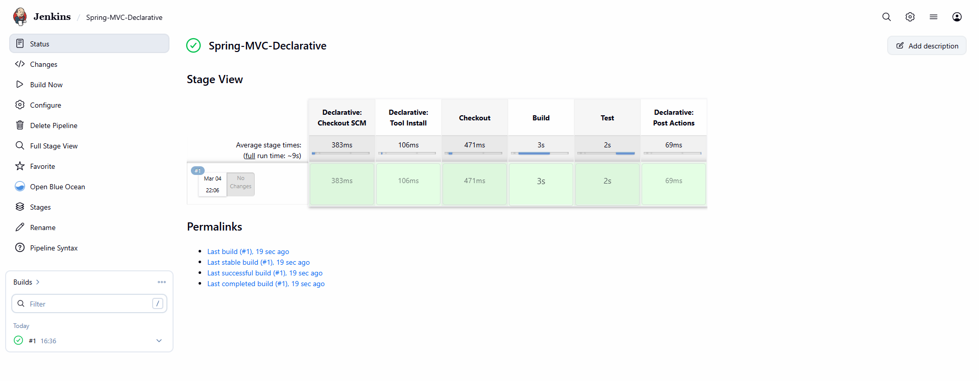
✔ WAR file generated under target/
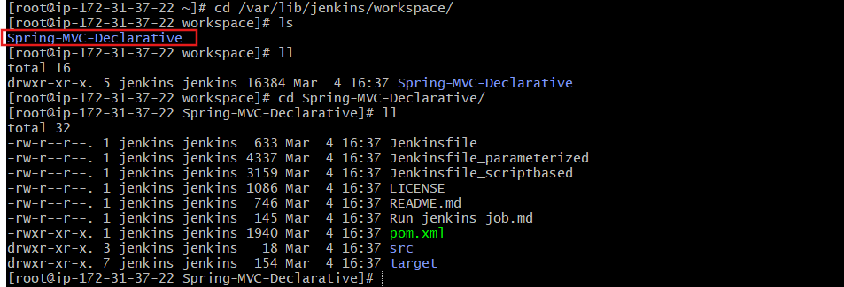

- Create one Scripted pipeline job
Source Code: https://github.com/shaikhshahbazz/spring3-mvc-maven-xml-hello-world-1.git
Steps
- New Item → Spring-MVC-Scripted
- Select Pipeline
- Choose Pipeline script (not from SCM)
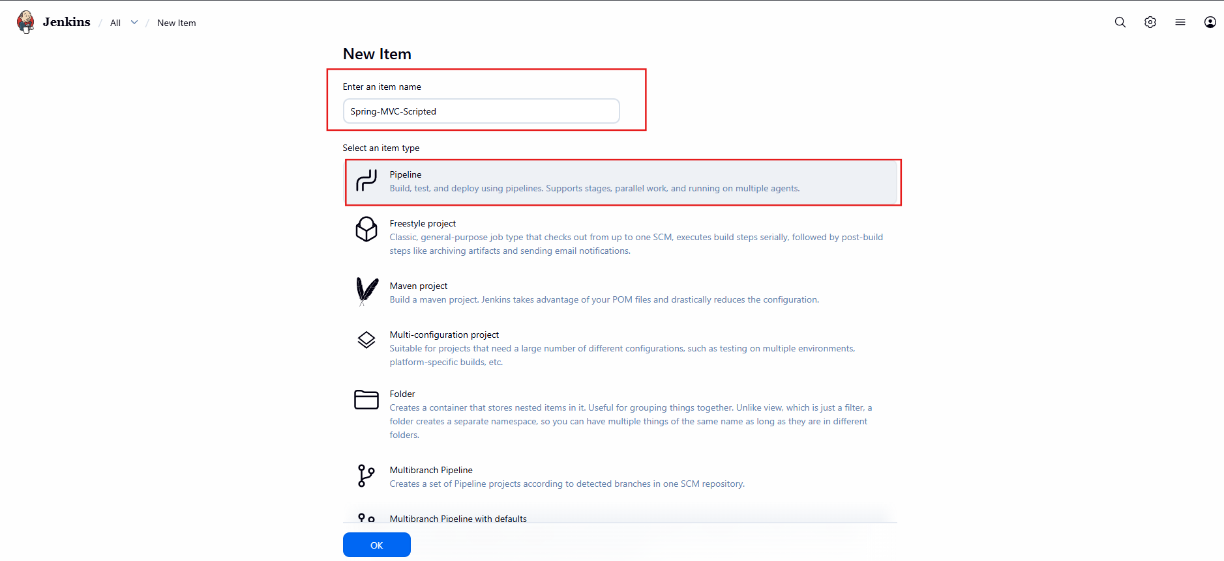
Scripted Pipeline Code
node {
stage('Checkout') {
git 'https://github.com/shaikhshahbazz/spring3-mvc-maven-xml-hello-world-1.git'
}
stage('Build') {
sh 'mvn clean package'
}
stage('Test') {
sh 'mvn test'
}
if (currentBuild.result == null || currentBuild.result == 'SUCCESS') {
echo "Build Successful"
} else {
echo "Build Failed"
}
}
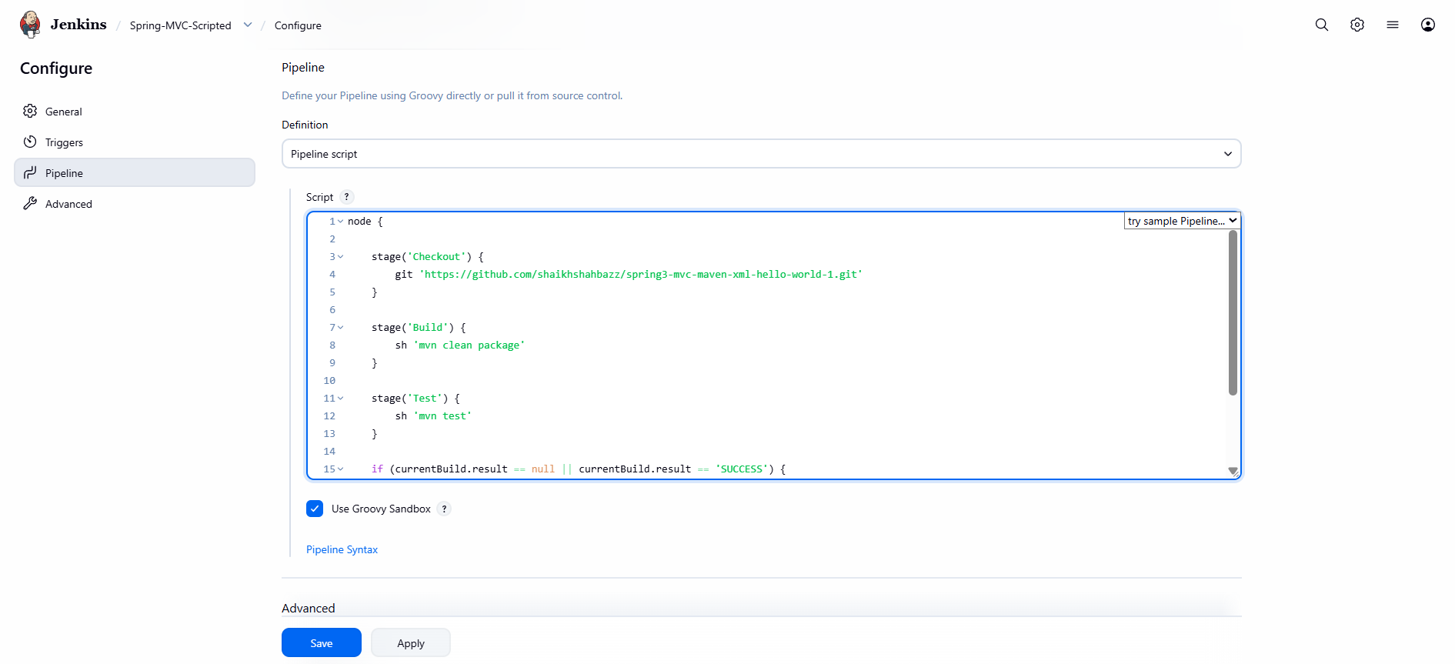
Explanation
- node {} → Allocates executor
- Scripted uses Groovy logic
- More flexible than declarative

Validation
✔ Console shows Maven build logs
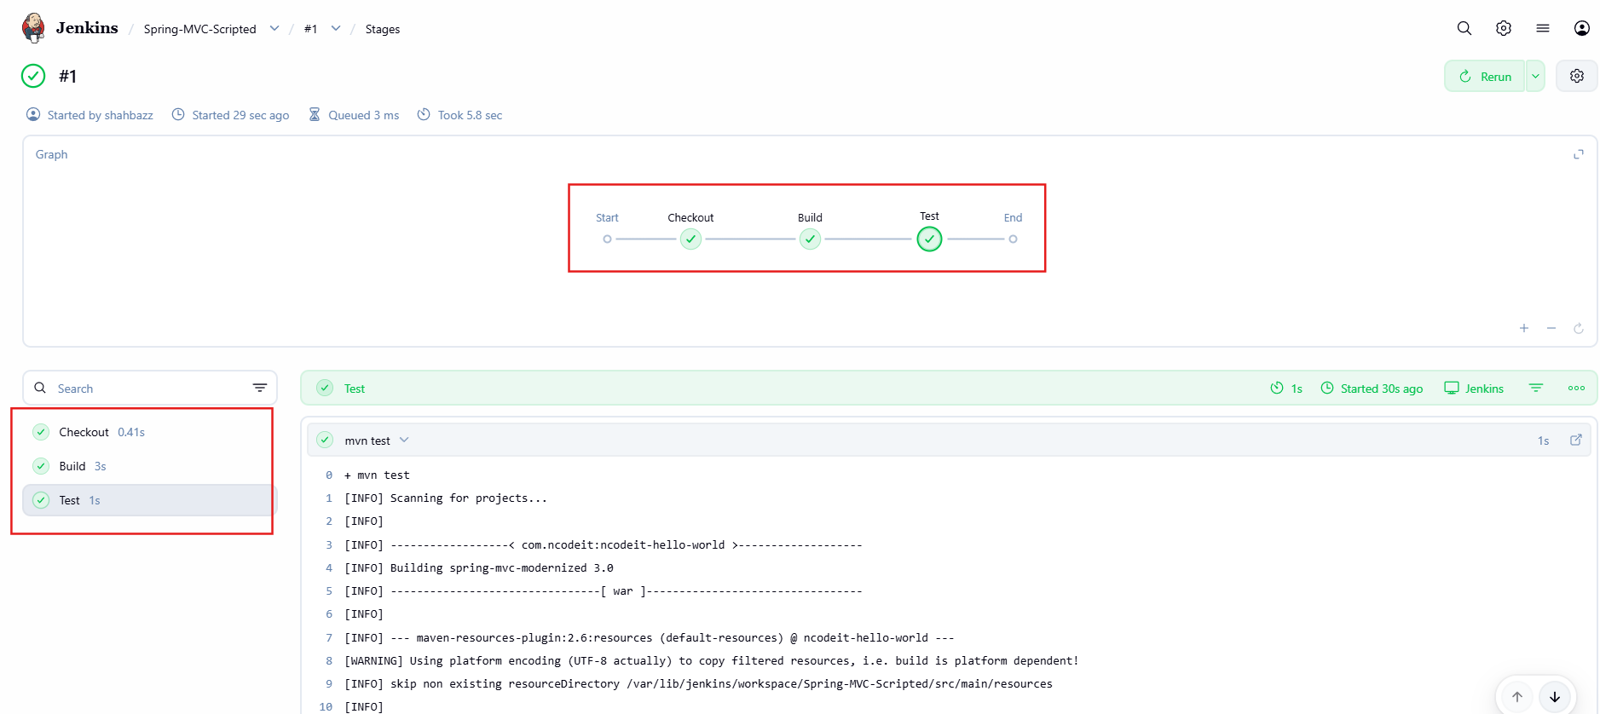
✔ Status turns green
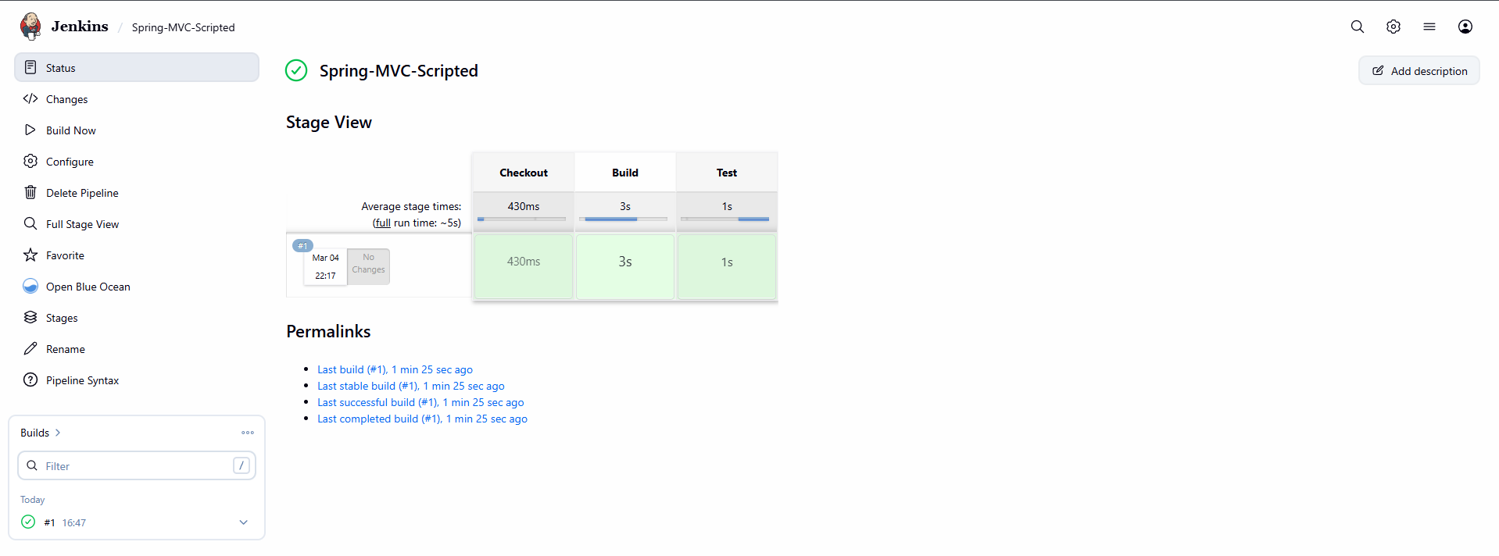

- Create one Parameterized job
Source Code: https://github.com/shaikhshahbazz/spring3-mvc-maven-xml-hello-world-1.git
Steps
- New Item → Spring-MVC-Parameterized
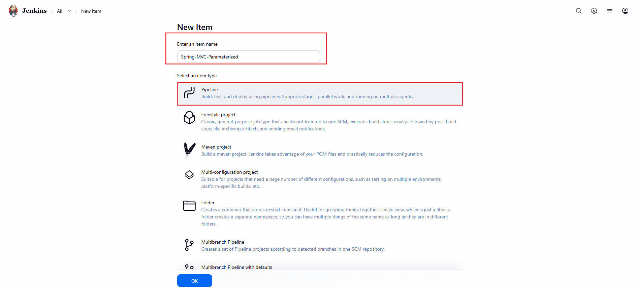

- Check This project is parameterized
- Add Parameters:
- String Parameter:
  - Name: BRANCH
  - Default: master
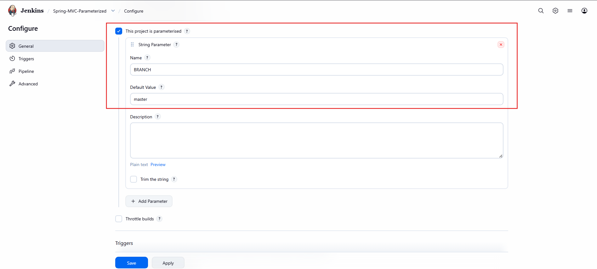
Jenkinsfile
pipeline {
agent any
parameters {
string(name: 'BRANCH', defaultValue: 'master', description: 'Git Branch')
}
stages {
stage('Checkout') {
steps {
git branch: "${params.BRANCH}",
url: 'https://github.com/shaikhshahbazz/spring3-mvc-maven-xml-hello-world-1.git'
}
}
stage('Build') {
steps {
sh 'mvn clean package'
}
}
}
}
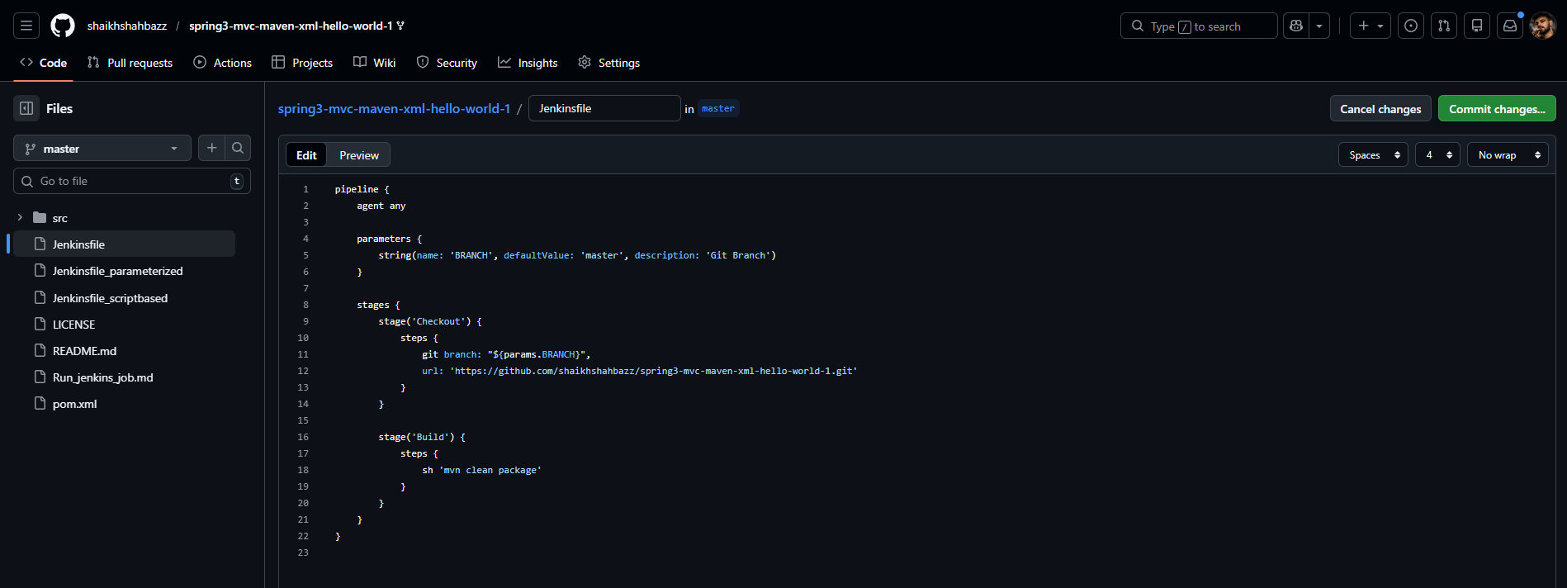
Explanation
- parameters {} → Defines user inputs
- ${params.BRANCH} → Dynamic branch selection

Validation
✔ “Build with Parameters” button visible
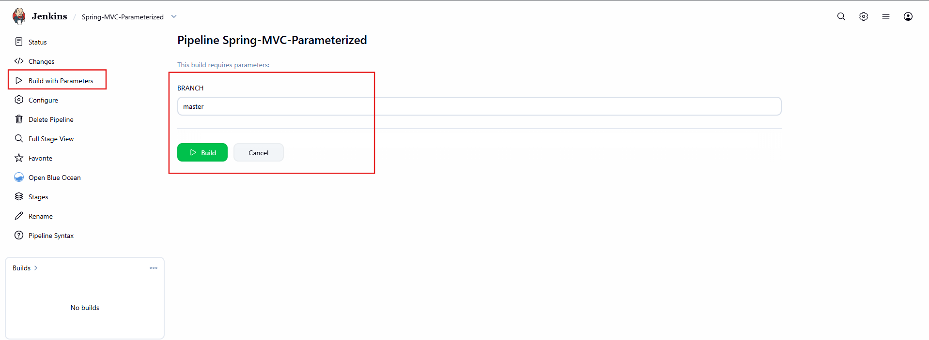
✔ Build runs based on entered branch
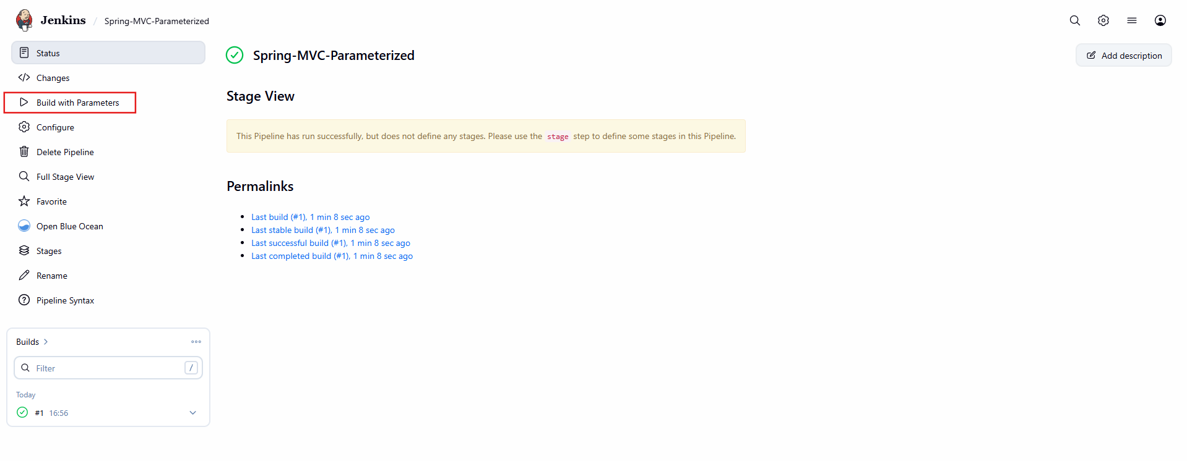
- Write sample skeleton for Declarative and Scripted pipelines
Declarative Skeleton
pipeline {
agent any

stages {

stage('Checkout') {
steps {
echo 'Checking out source code...'
}
}

stage('Build') {
steps {
echo 'Building application...'
}
}

stage('Test') {
steps {
echo 'Running tests...'
}
}

}

post {
success {
echo 'Build Successful!'
}
failure {
echo 'Build Failed!'
}
always {
echo 'Pipeline Completed.'
}
}
}

Scripted Skeleton
node {

stage('Checkout') {
echo "Checking out source code..."
}

stage('Build') {
echo "Building the application..."
}

stage('Test') {
echo "Running tests..."
}

}

- Create one Declarative job
Source Code: https://github.com/shaikhshahbazz/sabear_simplecutomerapp.git
Declarative Job
Repo: sabear_simplecutomerapp
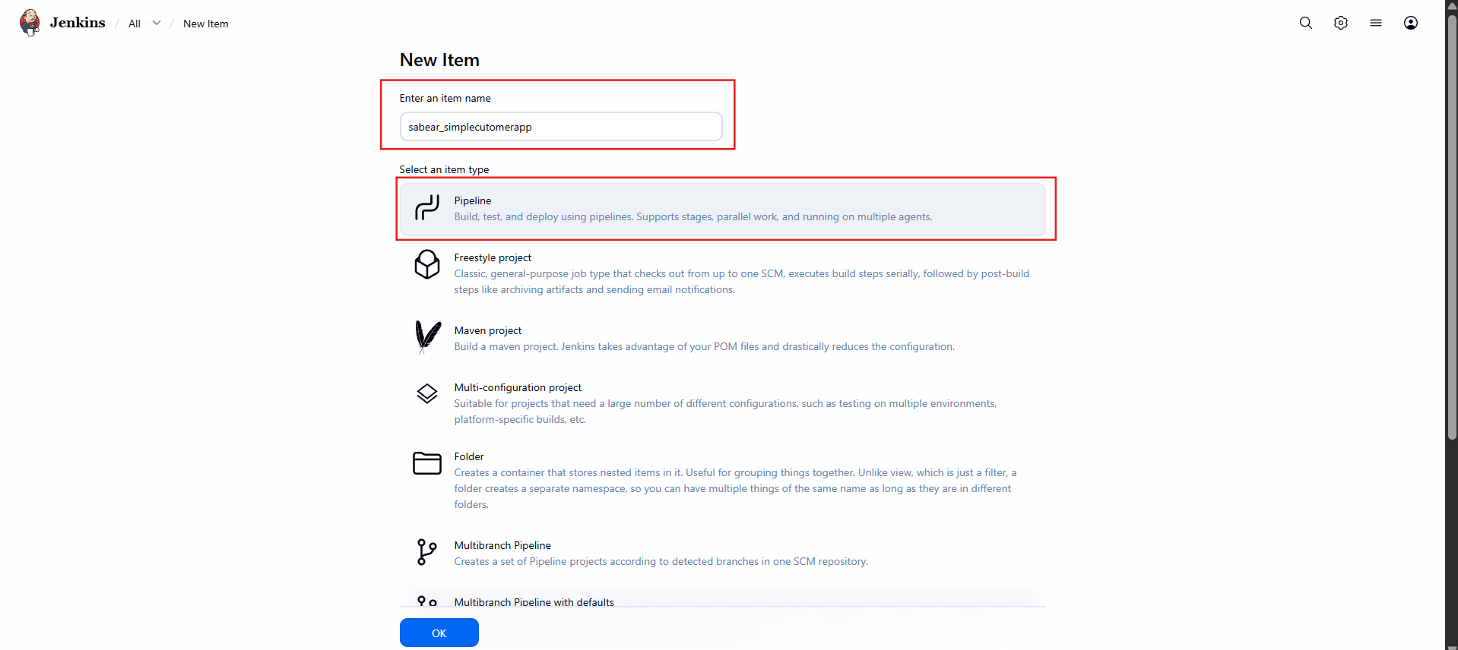

Add Declarative Jenkinsfile
In the Pipeline section:
- Definition: Pipeline script from SCM
- SCM: Git
- Repository URL: https://github.com/shaikhshahbazz/sabear_simplecutomerapp.git
- Branch: */master (or change if different)
- Script Path: Jenkinsfile

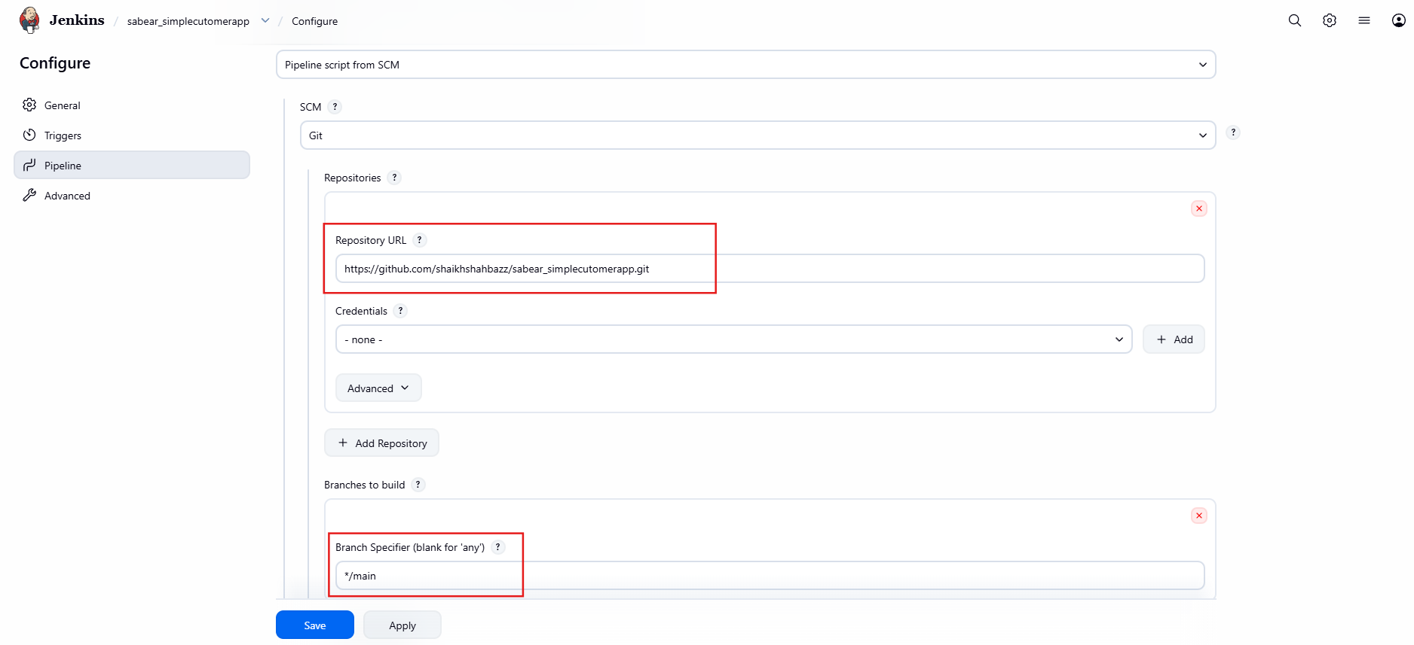

Jenkinsfile
pipeline {
agent any

tools {
maven 'Maven3'
jdk 'JDK17'
}

stages {

stage('Checkout') {
steps {
git url: 'https://github.com/shaikhshahbazz/sabear_simplecutomerapp.git'
}
}

stage('Build') {
steps {
sh 'mvn clean package'
}
}

stage('Archive') {
steps {
archiveArtifacts artifacts: '**/target/*.jar', fingerprint: true
}
}
}

post {
success {
echo 'Build completed successfully!'
}
failure {
echo 'Build failed!'
}
}
}
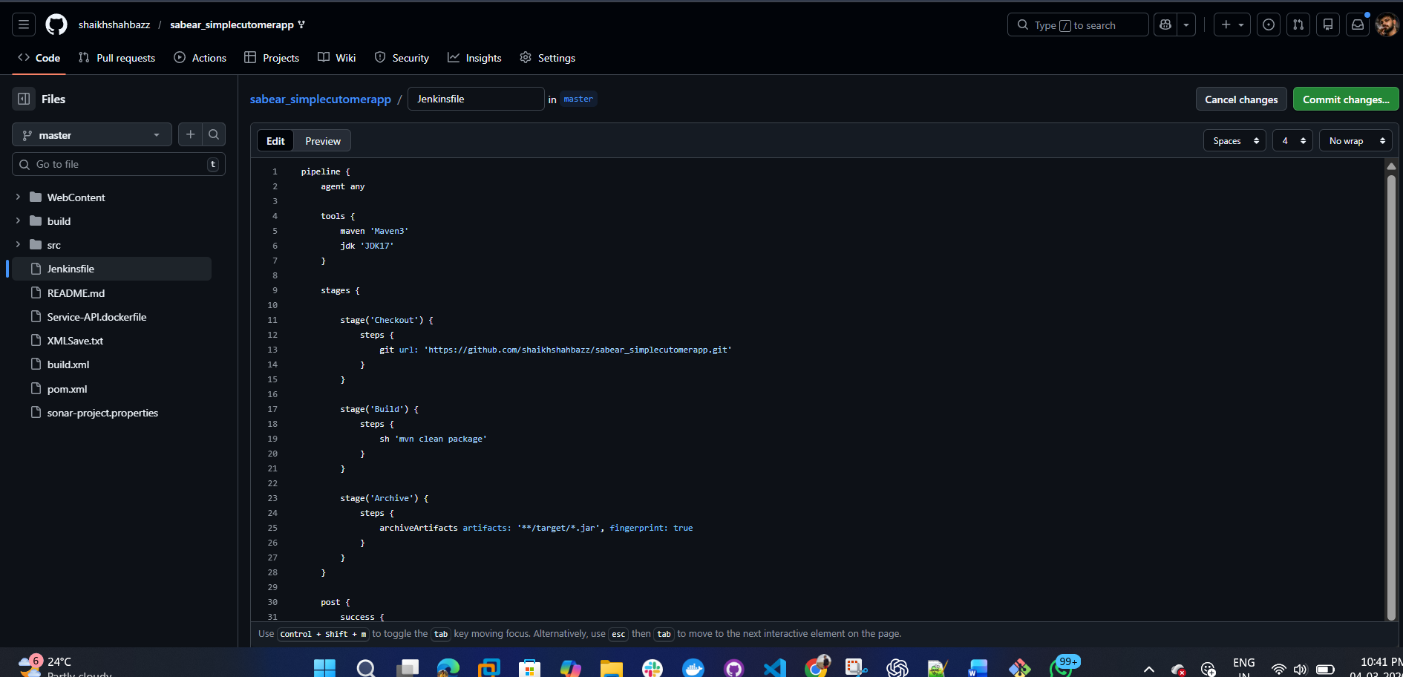

Validation
✔ Build Success
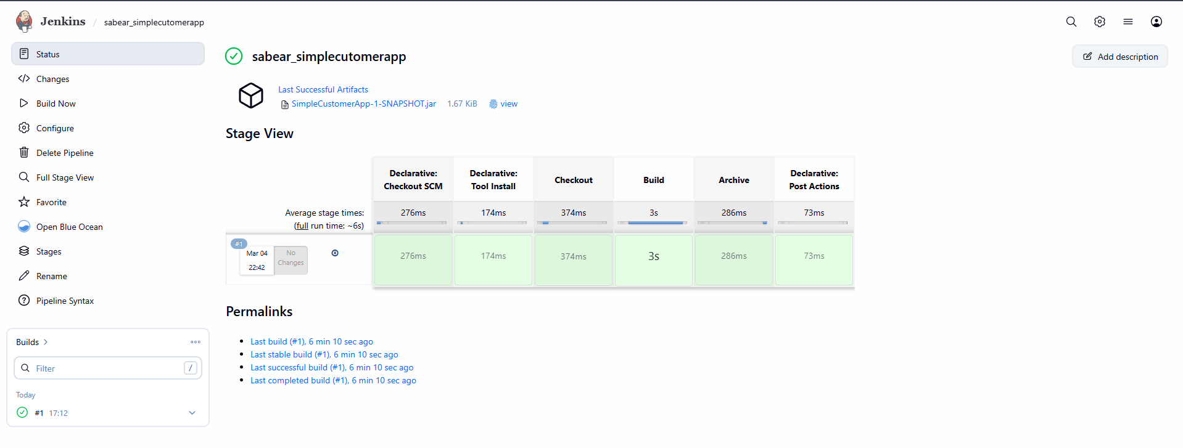

✔ Artifact in target/
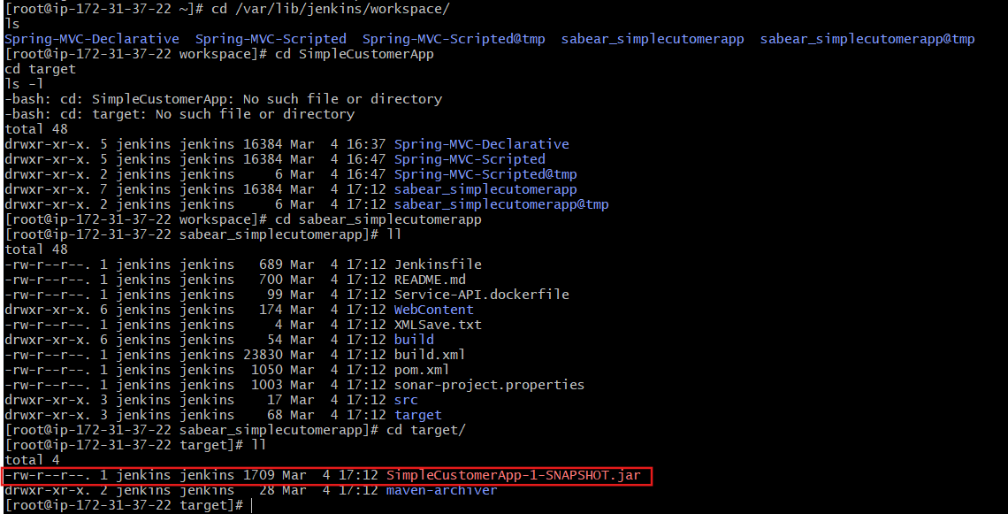

- Create one Declarative job
Source Code: https://github.com/shaikhshahbazz/Trading-UI.git
Declarative Job
Step 1: Create Pipeline Job in Jenkins
- Go to Jenkins Dashboard
- Click New Item
- Enter name: Trading-UI
- Select Pipeline
- Click OK
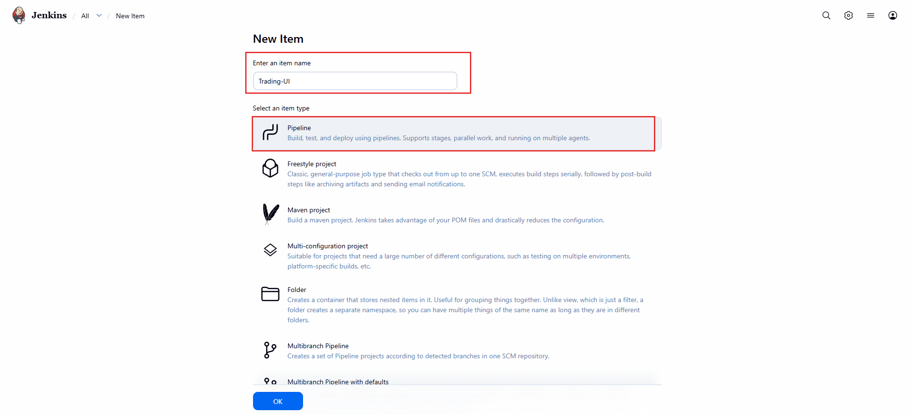

Step 2: Configure Pipeline from SCM
Scroll to Pipeline section:
- Definition → Pipeline script from SCM
- SCM → Git
- Repository URL:
https://github.com/shaikhshahbazz/Trading-UI.git

- Branch:
*/master
(Change to */master if repo uses master branch)
- Script Path:
Jenkinsfile
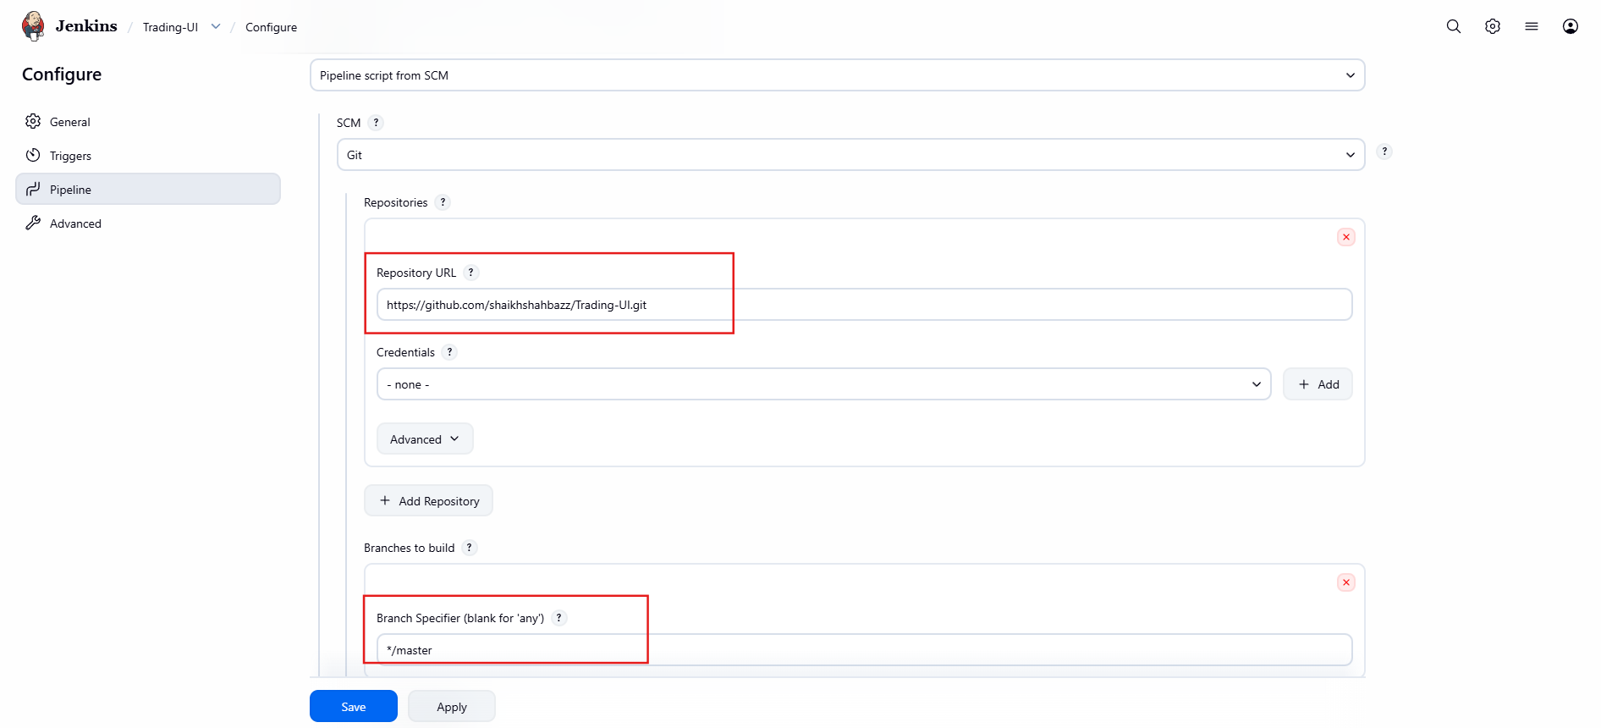
Step 3: Add Declarative Jenkinsfile
Since this is a UI project, it is most likely:
React / Angular / Node-based frontend
pipeline {
agent any
tools {
nodejs 'Node18'
}
stages {
stage('Checkout') {
steps {
git url: 'https://github.com/shaikhshahbazz/Trading-UI.git'
}
}
stage('Install Dependencies') {
steps {
sh 'npm install'
}
}
stage('Build') {
steps {
sh 'npm run build'
}
}
stage('Validate Build') {
steps {
sh 'ls -l'
}
}
}
post {
success {
echo 'UI Build Successful!'
}
failure {
echo 'UI Build Failed!'
}
}
}
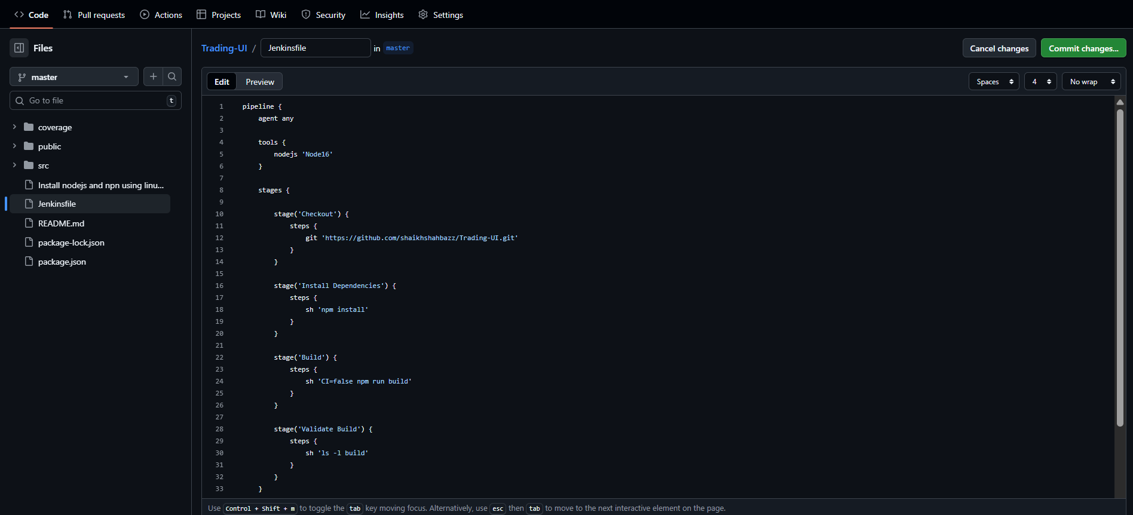
Step 4: Configure NodeJS in Jenkins
Go to:
Manage Jenkins → Global Tool Configuration
Add:
- NodeJS
- Name: Node18
- Install automatically
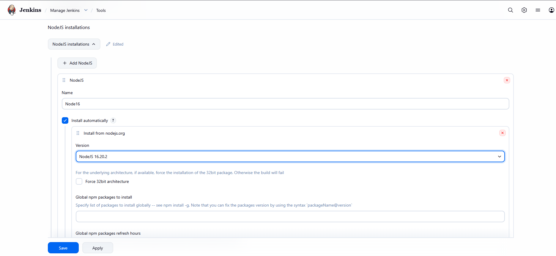

Step 5: Build Now
Click:
Build Now
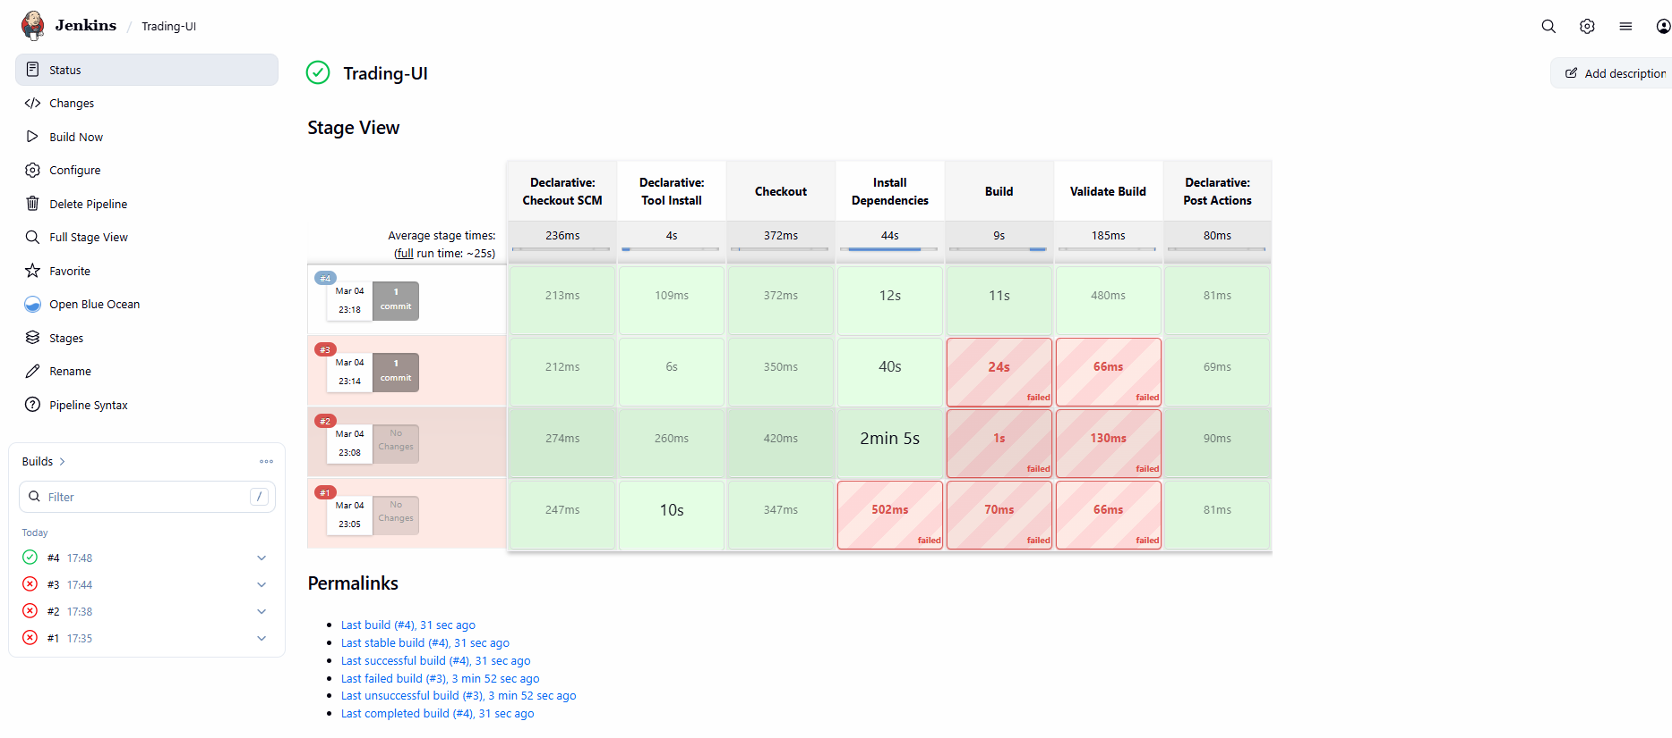
Validation
Go to Workspace
cd /var/lib/jenkins/workspace/Trading-UI
ls
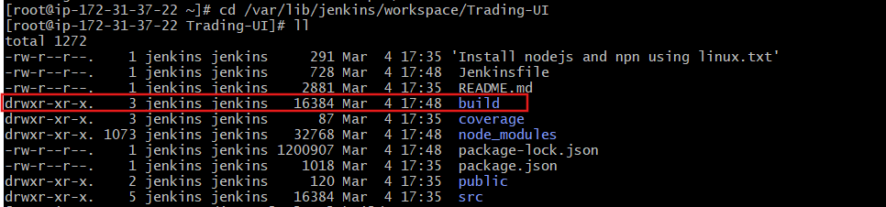
Check Build Contents
ls -l build
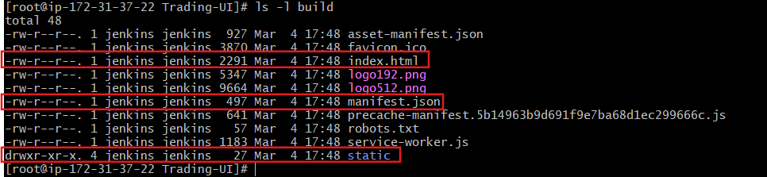

  - Serve Build Locally
If you want to verify it actually runs:
Install serve:
npm install -g serve
Run:
serve -s build
It will show:
Local: http://localhost:3000
Open in browser → app should load.
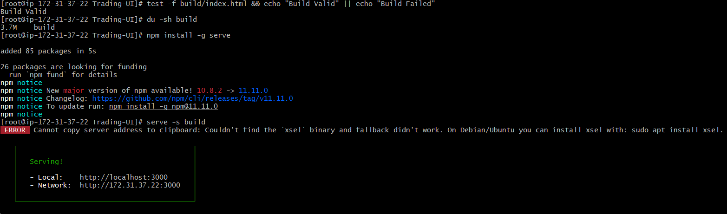
Access in Browser
Since this is an EC2 / Jenkins server, use:
http://<YOUR-EC2-PUBLIC-IP>:3000
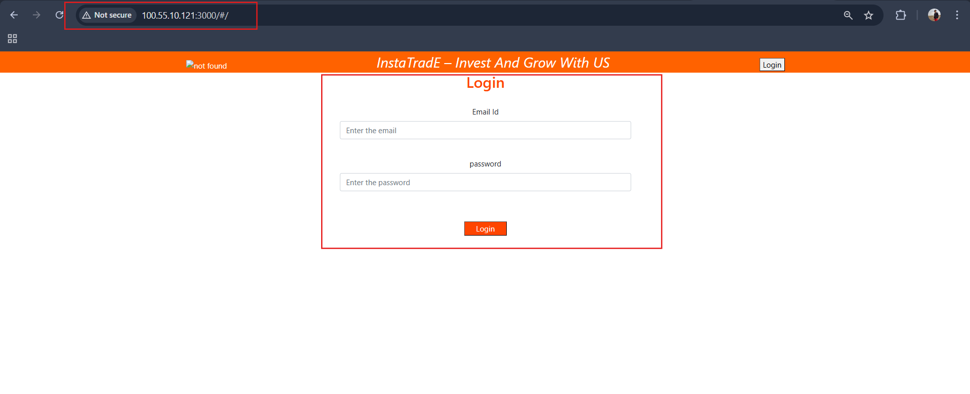

- Execute parallel stages using Jenkins pipeline for any sample job
Execute Parallel Stages
Step-by-Step: Create Parallel Pipeline Job
Step 1 — Open Jenkins Dashboard
In browser open:
http://<your-public-ip>:8080
Step 2 — Create New Job
- Click New Item
- Enter name: parallel-stage
- Select:
Pipeline
- Click OK
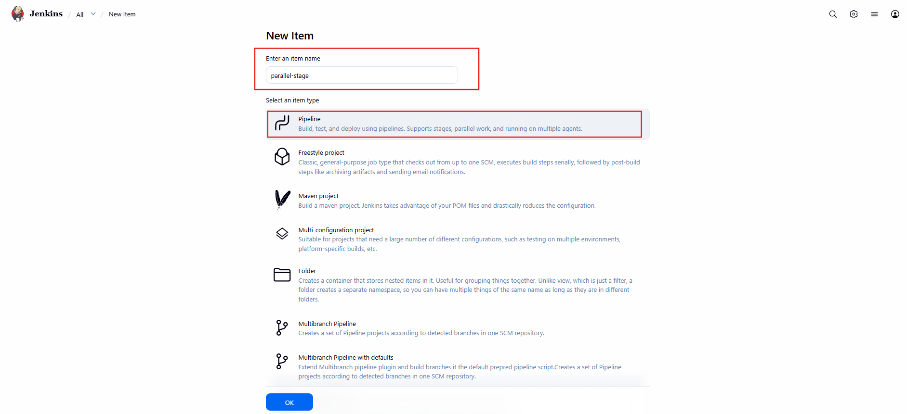
Step 3 — Add Pipeline Script
Scroll down to:
Pipeline
Set:
Definition → Pipeline script
pipeline {
agent any
stages {
stage('Build') {
steps {
echo "Building..."
sh 'sleep 5'
}
}
stage('Parallel Execution') {
parallel {
stage('Unit Test') {
steps {
echo "Running Unit Test"
sh 'sleep 5'
}
}
stage('Integration Test') {
steps {
echo "Running Integration Test"
sh 'sleep 5'
}
}
stage('Code Analysis') {
steps {
echo "Running Code Analysis"
sh 'sleep 5'
}
}
}
}
stage('Deploy') {
steps {
echo "Deploying..."
}
}
}
}
Click Save.
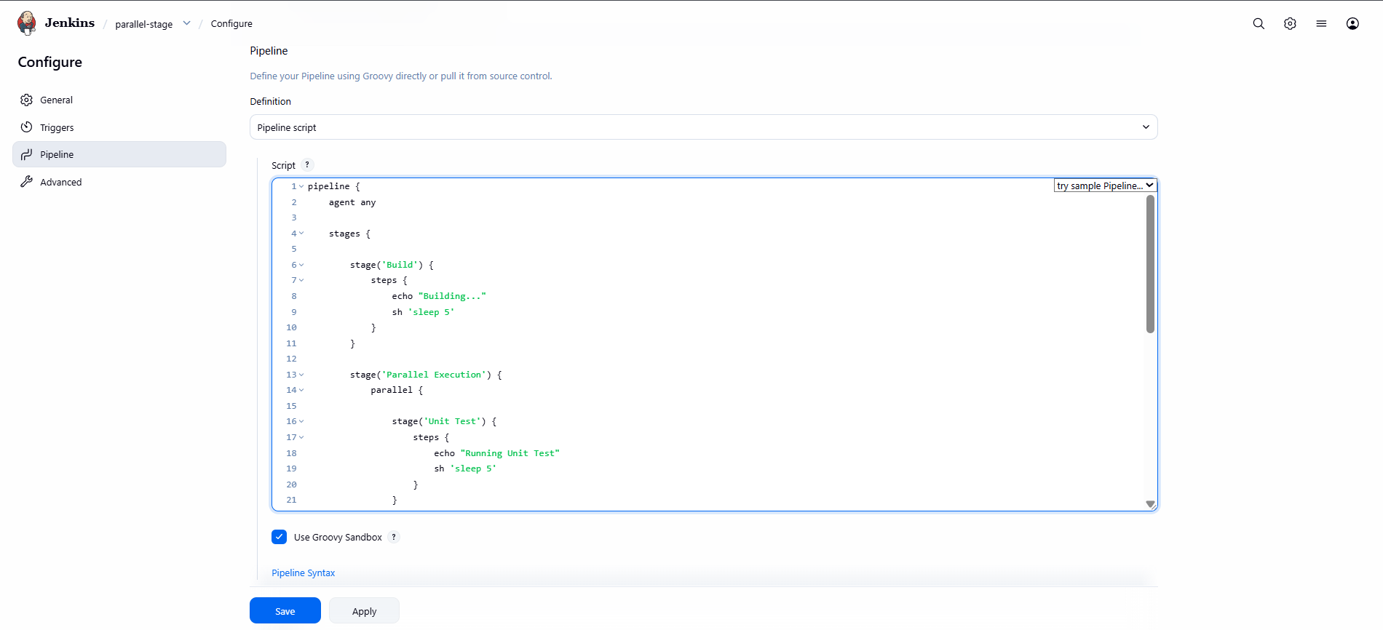
Step 4 — Run the Job
Click:
Build Now
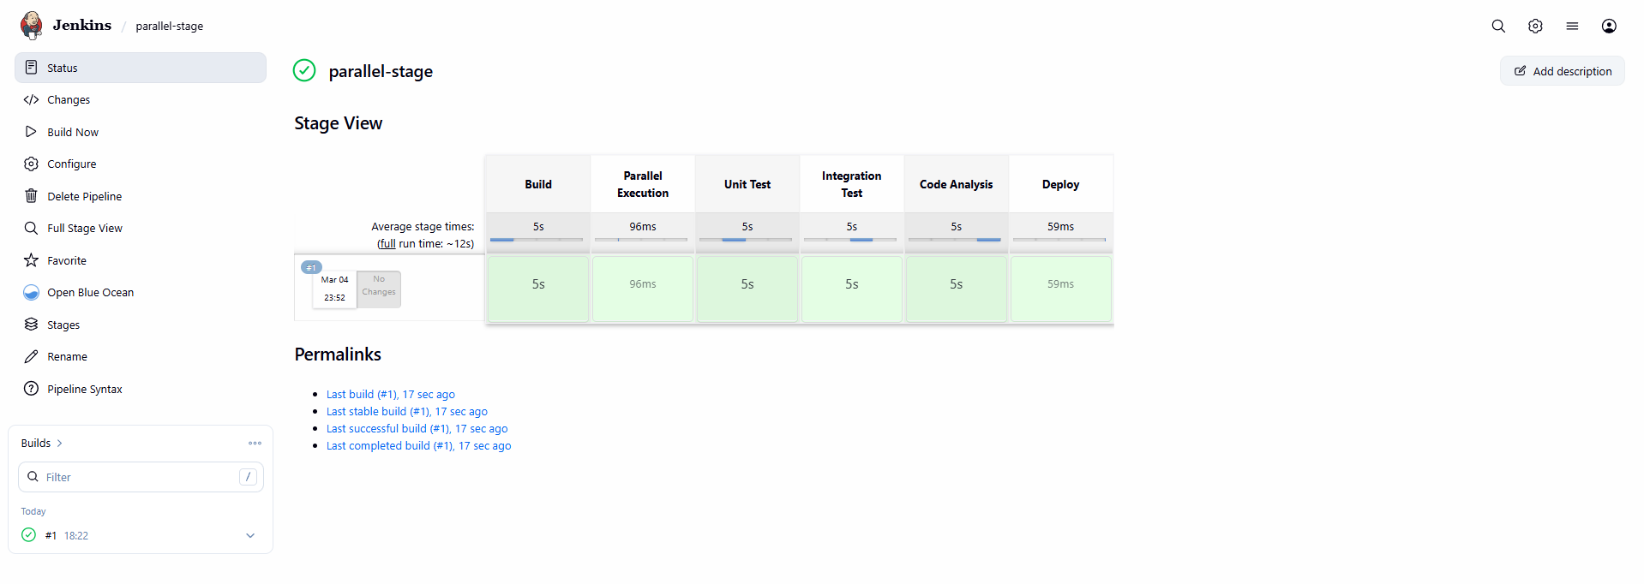

Step 5 — Verify Parallel Execution
Click the build number → Click Stage View
You will see:
Build → Parallel Execution (3 boxes side by side) → Deploy
The 3 stages run at the same time.
That confirms parallel execution
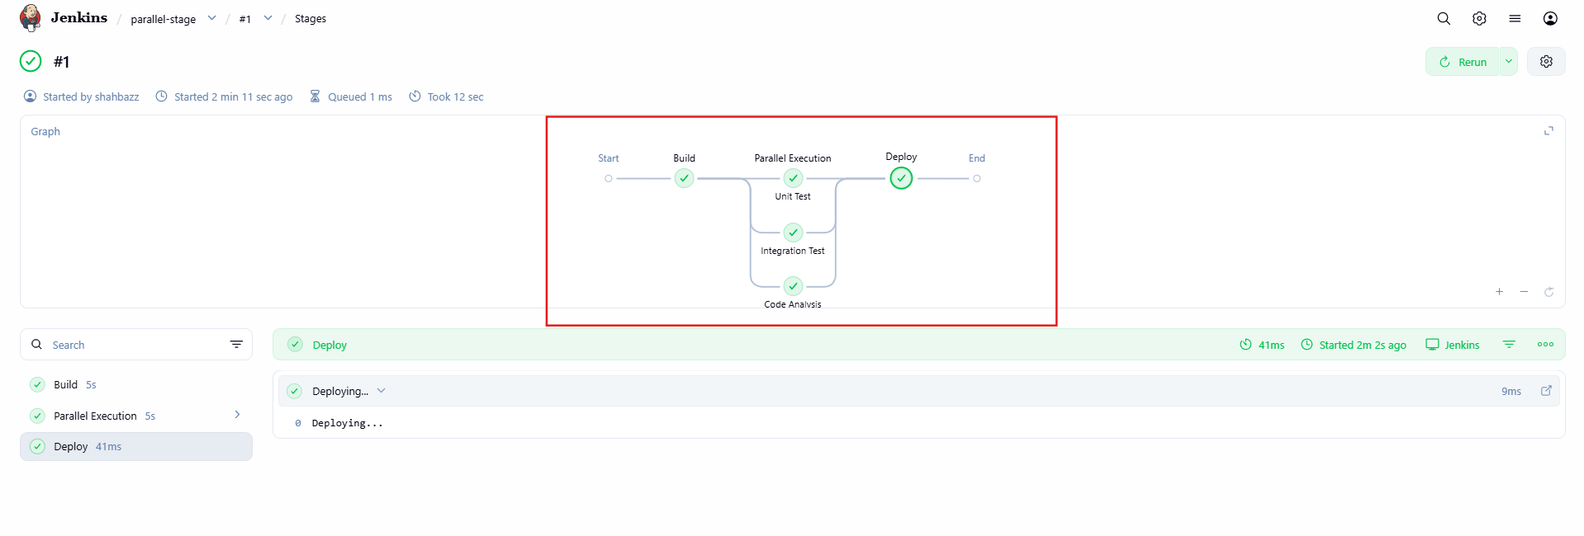

Explanation
- parallel {} runs stages simultaneously
- Reduces pipeline execution time
Validation
✔ Both stages run at same time
✔ Blue Ocean shows parallel branches
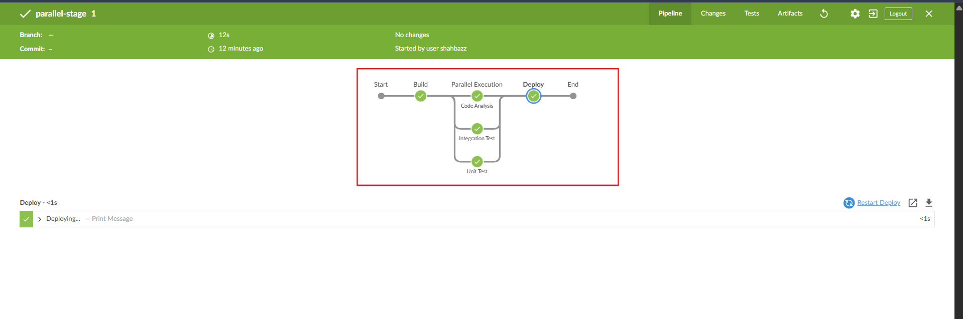

- Execute Jenkins pipeline stages using shared libraries
Reference: https://phoenixnap.com/kb/jenkins-shared-library

STEP 1 — Create Shared Library Structure
On your system (or GitHub repo), create this structure:
jenkins-shared-lib/
│
├── vars/
│ └── buildApp.groovy
│
└── src/

Create buildApp.groovy
Inside vars/ folder create:
def call() {
stage('Build') {
echo "Building application from Shared Library..."
sh 'sleep 3'
}
}
Commit and push this to your Git repository.
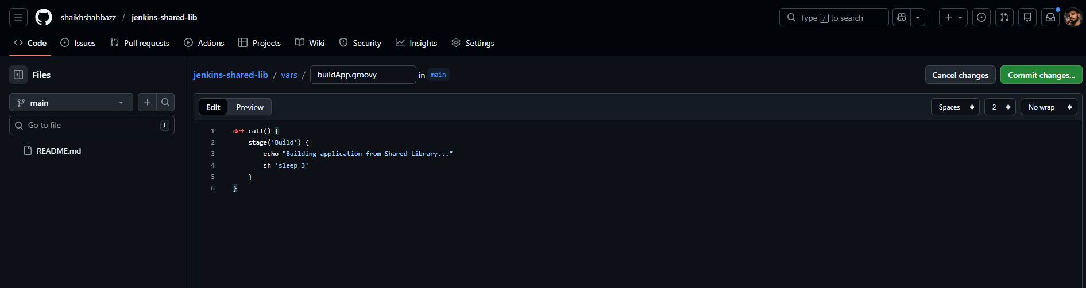
Repo url:
https://github.com/<your-username>/jenkins-shared-lib.git
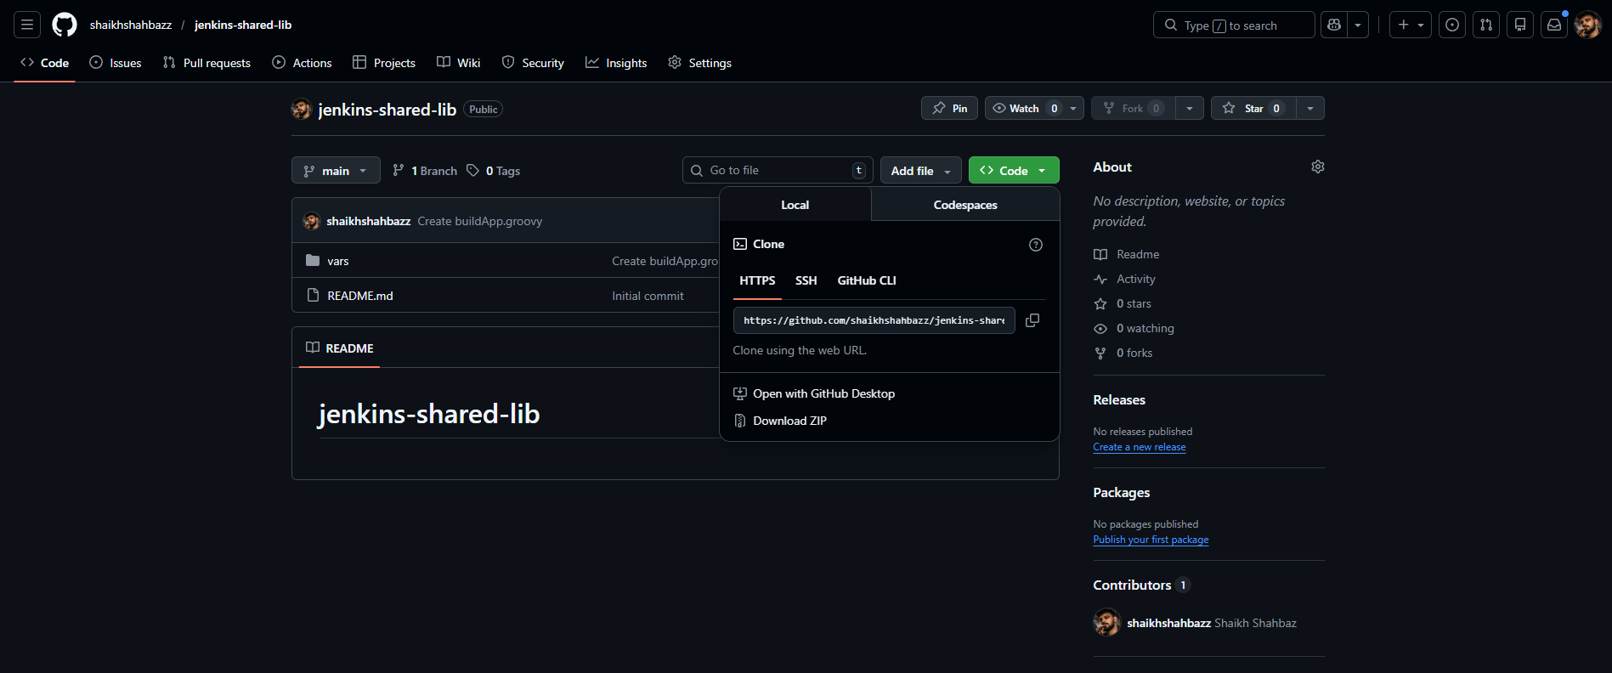

STEP 2 — Configure Shared Library in Jenkins
Now go to Jenkins UI:
- Click Manage Jenkins
- Click Manage Global Libraries
- Click Add
Fill:
Field | Value
Name | shared-lib
Default version | main
Retrieval method | Modern SCM
SCM | Git
Repository URL | your Git repo URL
Click Save
Now Jenkins can use this library globally.
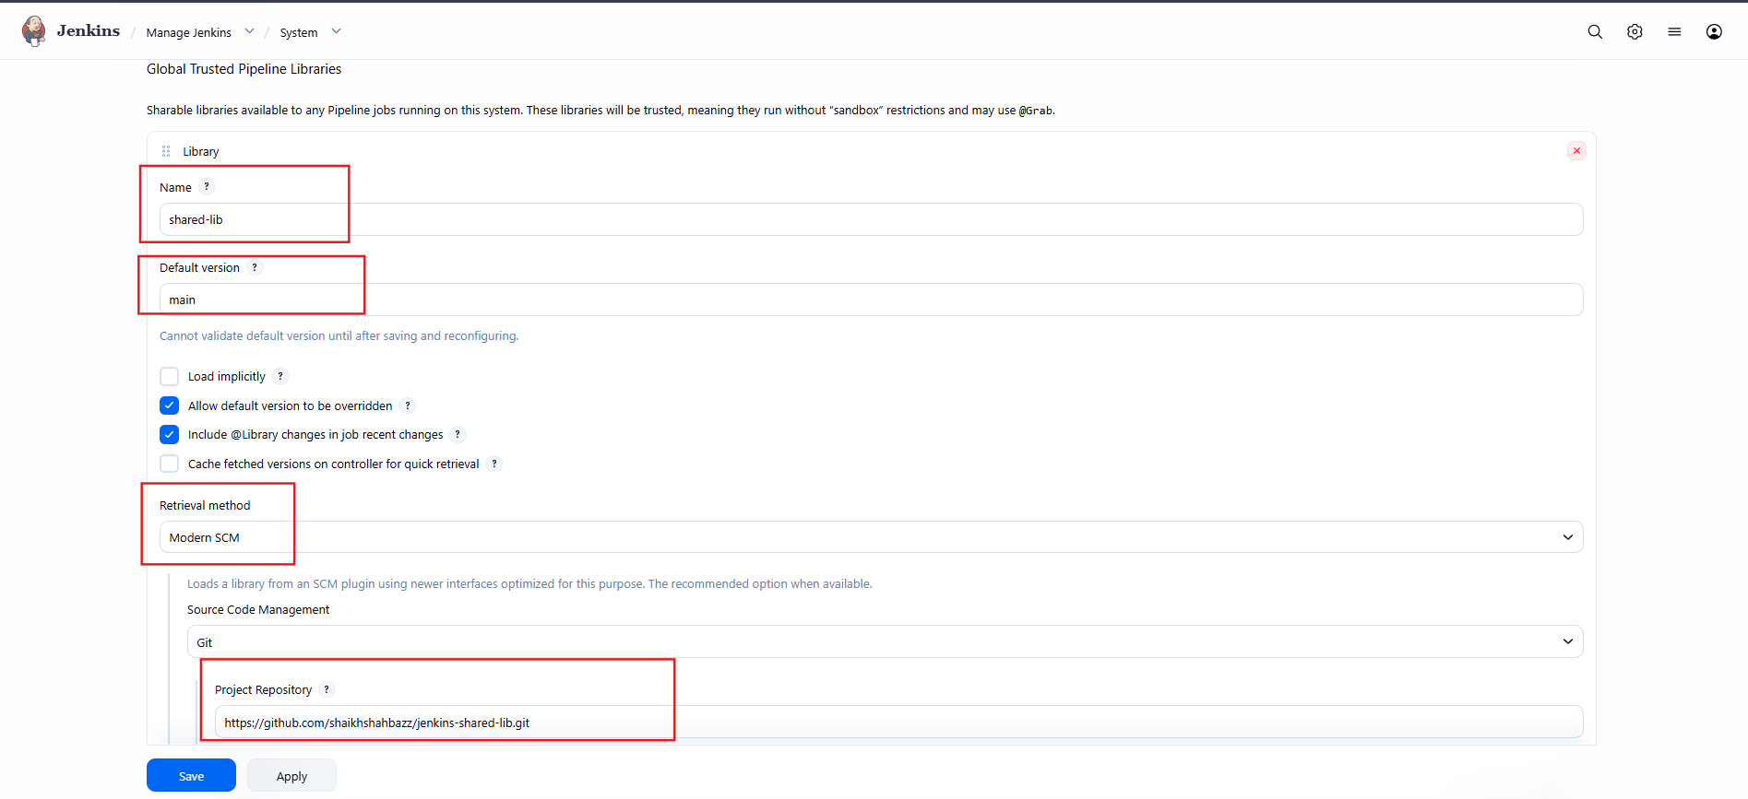

STEP 3 — Create Pipeline Job
- Click New Item
- Name: shared-lib-demo
- Select Pipeline
- Click OK
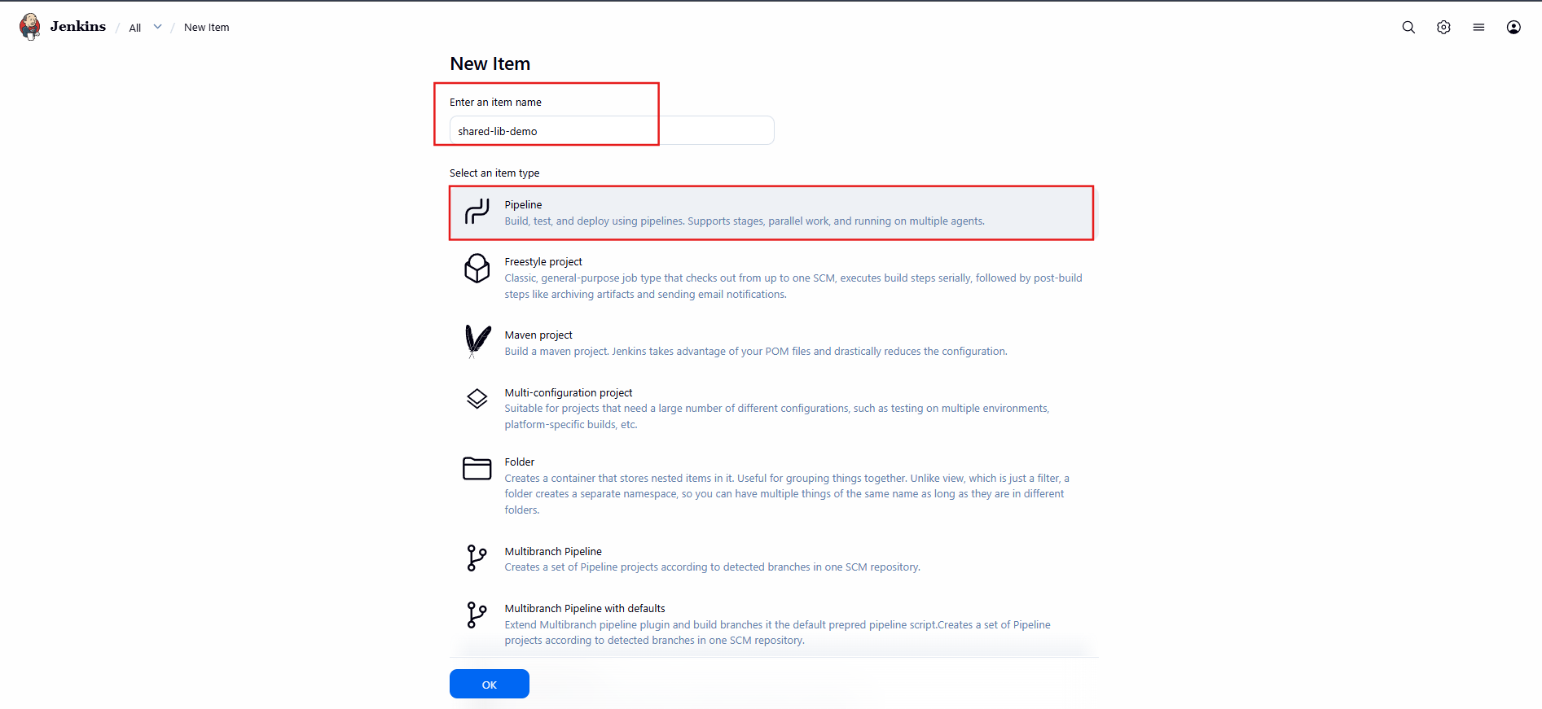
STEP 4 — Use Shared Library in Pipeline
In Pipeline script section paste:
@Library('shared-lib') _
pipeline {
agent any
stages {
stage('Start') {
steps {
echo "Pipeline Started"
}
}
stage('Build from Library') {
steps {
buildApp()
}
}
stage('Deploy') {
steps {
echo "Deploying Application..."
}
}
}
}
Click Save
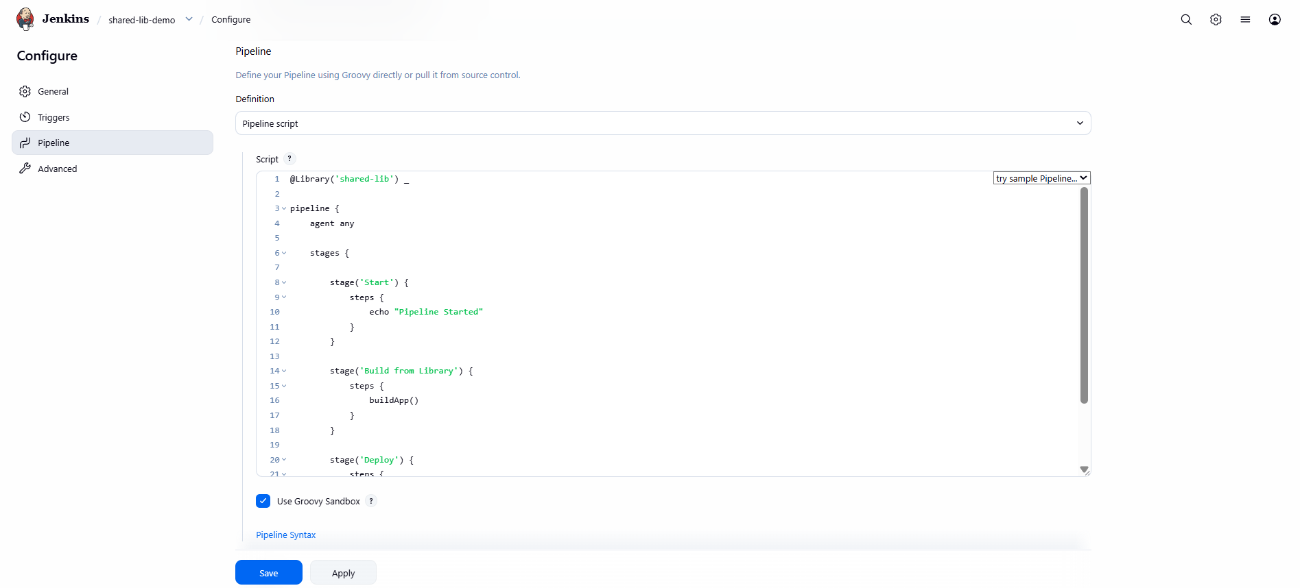
STEP 5 — Run the Job
Click:
Build Now
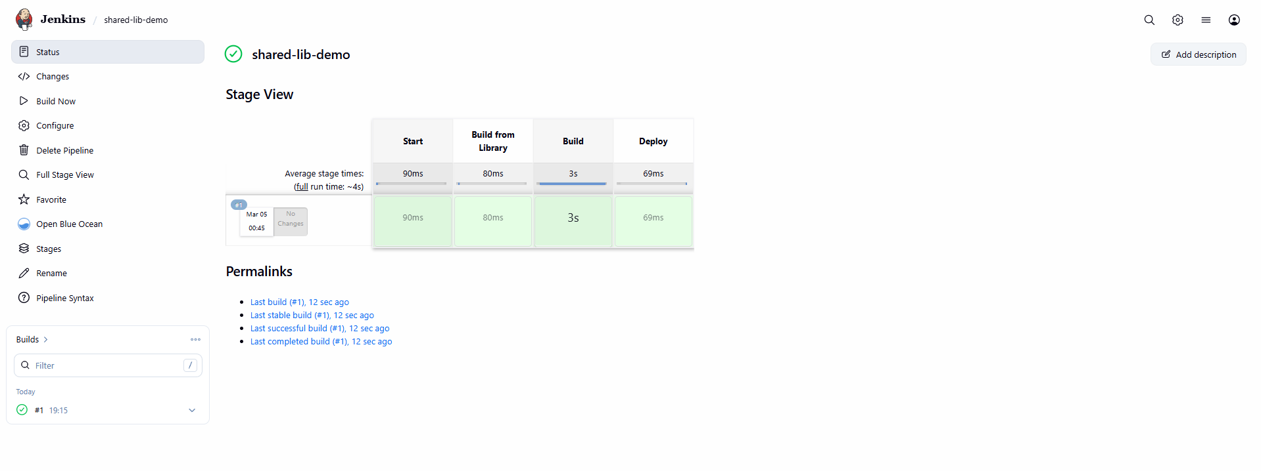
STEP 6 — Verify Execution
Open Console Output.
You should see:
Pipeline Started
Building application from Shared Library...
Deploying Application...
That confirms shared library execution
